Personal Portfolio
I’m a member from the Group 42. This group consists of 7 members including 3 computer science students and 4 Information system students. The following artefacts are my contribution to the project.
·Creating and developing user stories. Our team firstly get some requirements from the client team and then we analyzed them. According to the special requirements, I came up with some ideas about the user stories and developed them. They are about the uploading, searching items and downloading files. I also gave some advice for the others to think about the user stories.
·Improving and refining the acceptance criteria. After creating the user stories, I seriously consider the client team. For the convenience of client team, I thought of some specific requirements for the both develop team and client team. In order to specify the requirements, I listed some necessary things that help complete the user story.
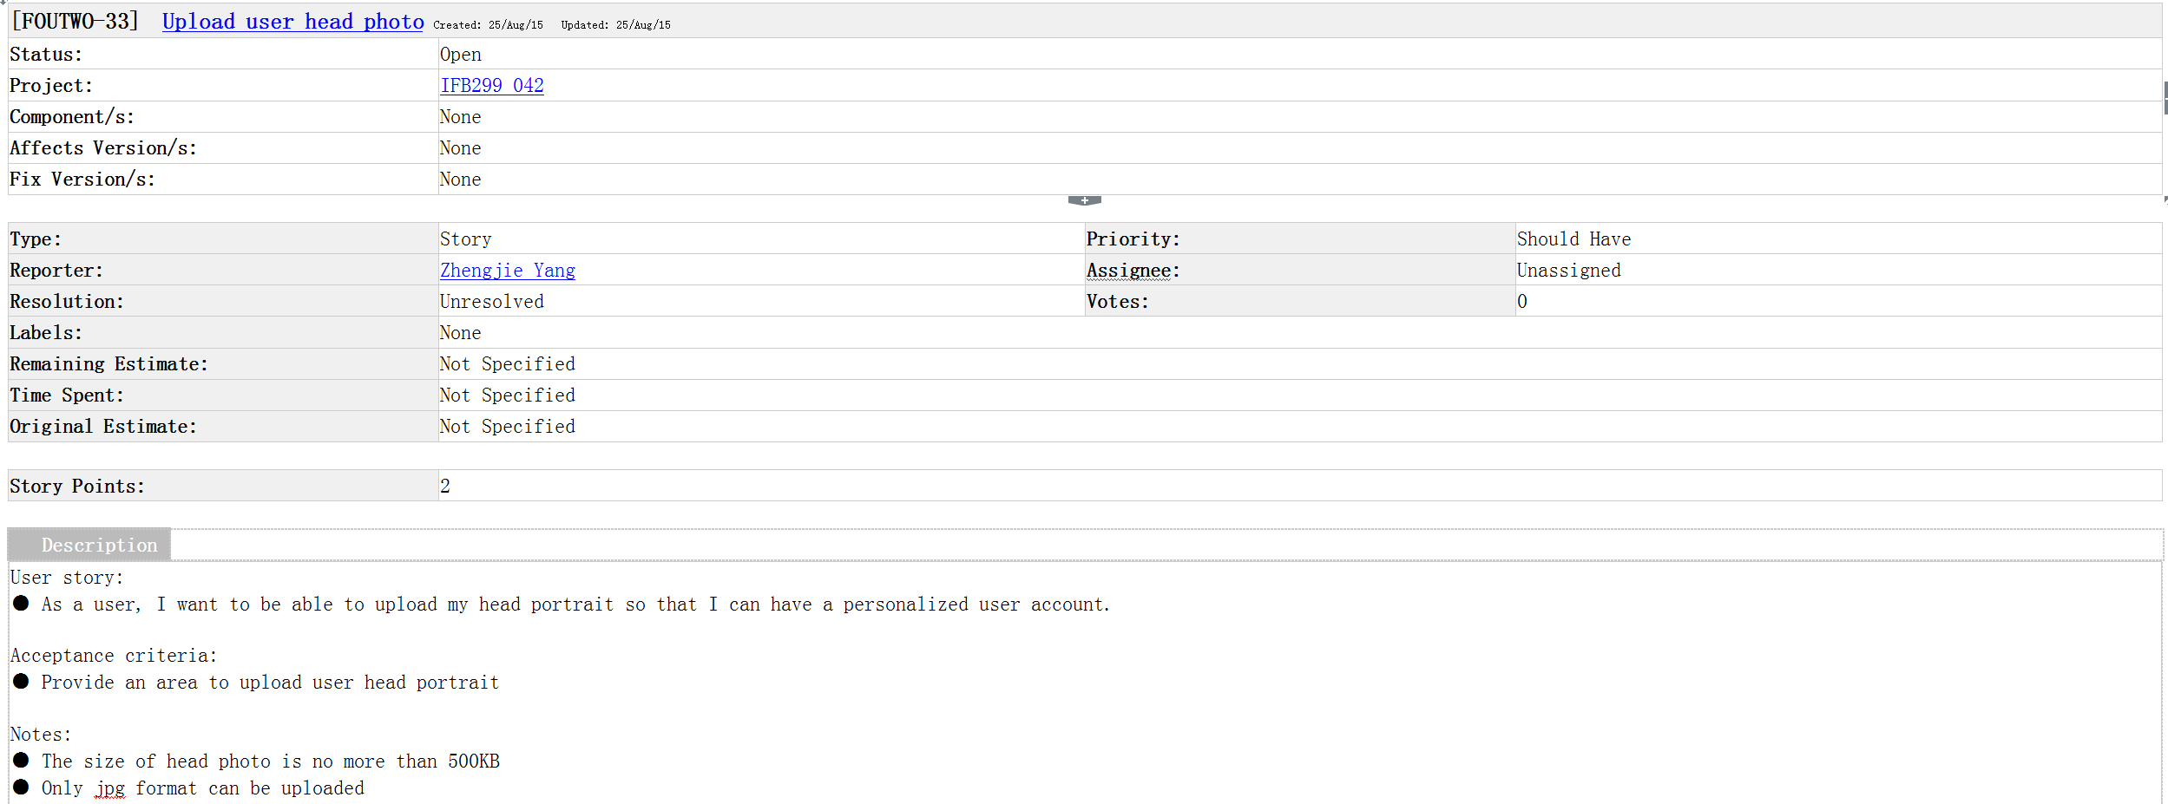
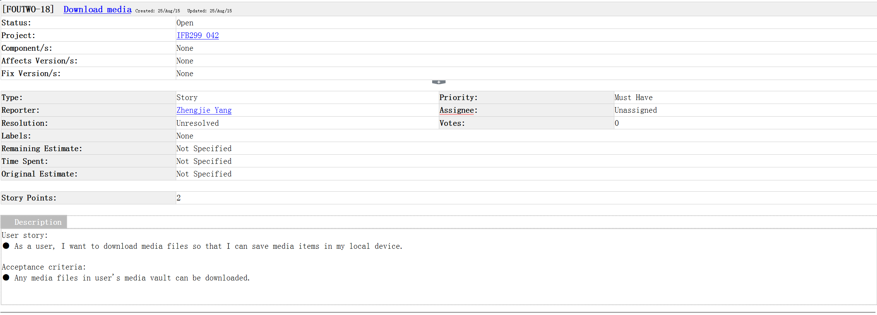

·Helping prioritize the user story with user points. In order to finish the release 1, I and my group members discussed the user points and sort out the user story. This is absolutely helpful for us to develop and design the product.
·Writing a peer review letter with Averson to give a feedback to the client team. After listening to the presentation from the client team. Our team concluded the product they showed and graded for the client. We all were impressed by the presenter and satisfied. However, they didn’t finish all the functions they show on the sprint 1. We hope that they can realize the release 1 before the workshop 9.
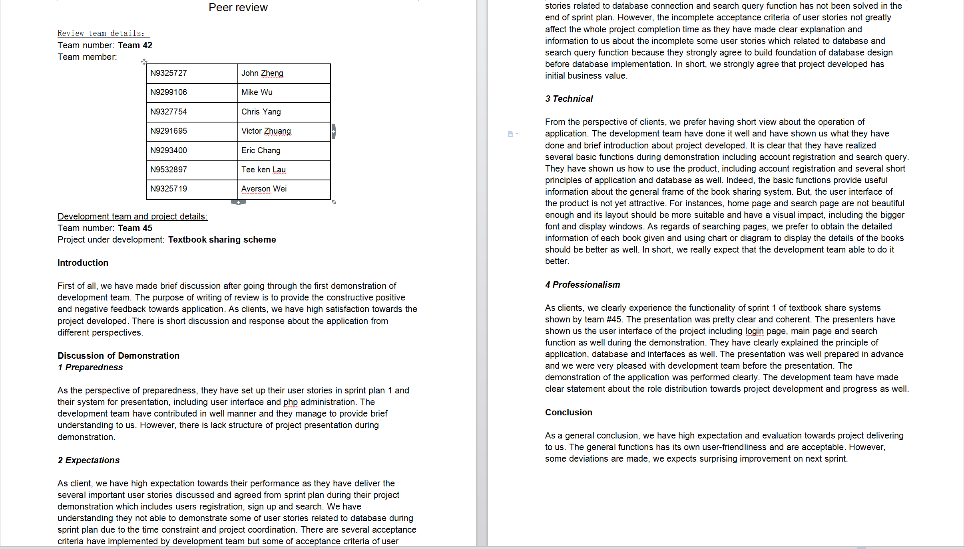
·Doing some black box testing. In order to ensure our product can work, I and Averson did some tests and finally got some results. Without knowing the codes of each function, we just logged in and test if it can work. We got some results that it cannot work and cannot link to database. So we went to find the developers and shared the ideas.

